Screenshot for the test result:

Create table and insert the few records as mentioned In the excel. 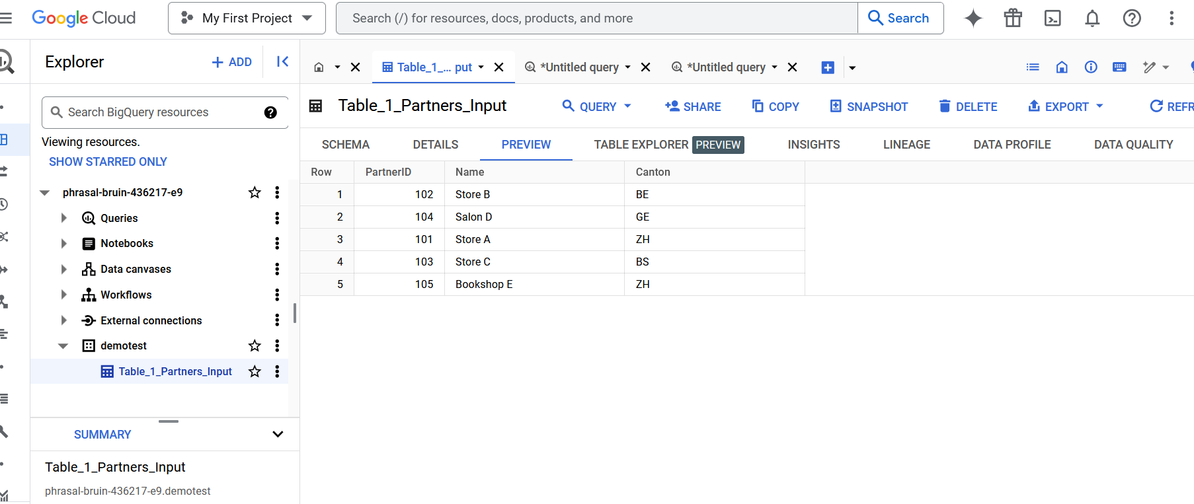

Run the script

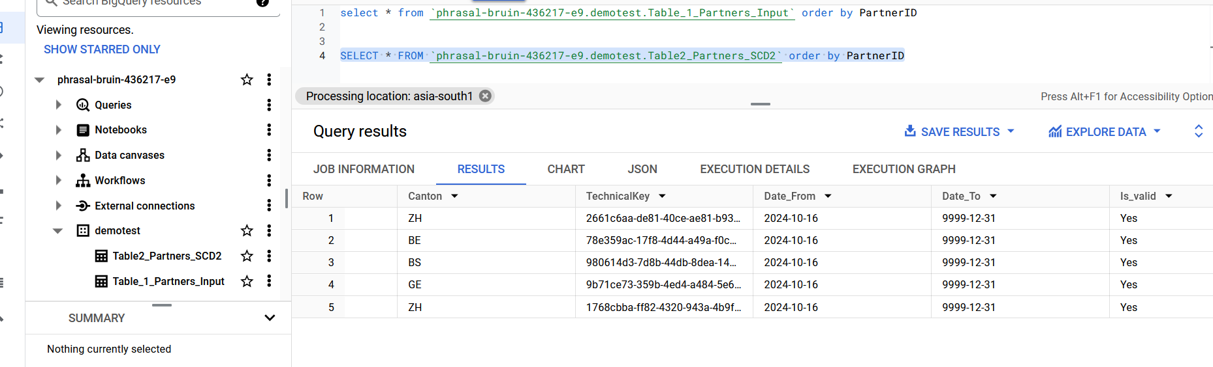

Update the Table_1_Partners_Input

update `phrasal-bruin-436217-e9.demotest.Table_1_Partners_Input`

set Canton = 'BS' where PartnerID = 105;

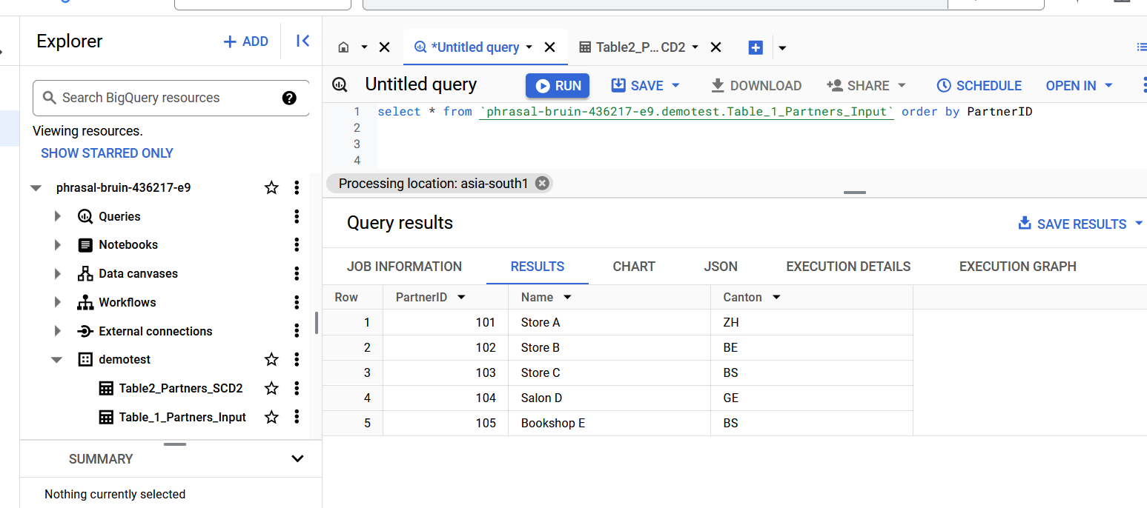

After Update query run the script, Here we can see the value is updated for Canton, Date_To and Is_valid.